*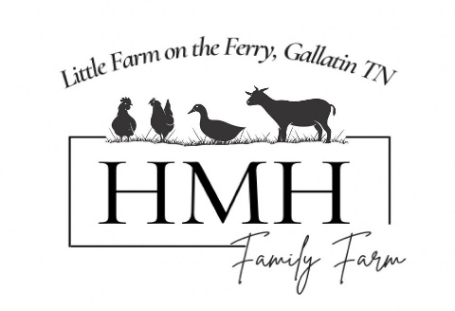*

*We are so excited about your interest in our goats! Please read our sales policy.*

\*Being added to the wish list is done so without a fee. Let us know from which pairing you are interested in or what you are looking for and you will be added to the list.

*To be added to the wish list please email us at* [*hmhsorting@gmail.com*](mailto:hmhsorting@gmail.com) *with your name, phone number and your wish!* 

\*Once the kid of your choice has been born, you will be notified. Once you have chosen your kid(s), you will then be asked for a $100 deposit per goat to reserve. This deposit is non refundable if you decide you no longer want the kid after you have reserved. Deposit will go towards purchase and remainder is due at pick up. Buyer is responsible for all safe transport and costs.

\*Registration included in the price of the kid and will be registered by HMH Farms and transferred when paid in full.

\*We have the right to terminate any sale at any time per our discretion with a full refund of purchase price.

\*Kids cannot be held past 12 weeks of age, if so, then a boarding fee of $5 a day will be added in addition to the cost of the kid(s).

\*Goats will be vaccinated, disbudded, tattooed, given coccidia prevention and come from a disease free, tested herd. Health of the animal will be in good condition when sold but the health of the animal is not guaranteed or our responsibility after it leaves our farm. It then becomes the buyer’s responsibility. Please, remember we are always here to help and want the best for the animal. Free mentorship and support come with every goat 😊

\*Once goat has left our farm, they cannot be returned (due to biosecurity) unless clean tested papers are shown.

\*When purchasing a goat from HMH farms, you agree that we have first right of refusal (first chance to buy the goat back) if you chose to sell the goat at any time and at the original or fair price.